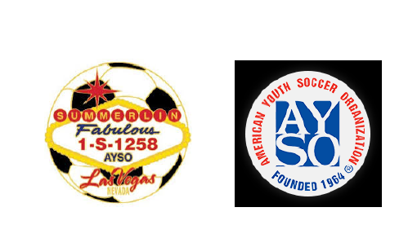
AYSO Region 1258 Board Meeting Minutes
Date: Sunday, February 22nd, 2026
Time: 6:30 PM
Location: Virtual via Zoom
Attendees will be checked:
Kim Wilkinson | Denise Kubajak | Jill Contreras
Mindy Veytia | Tim Downing | Andrew Contreras
Mike Bauder | Andrew Musgrove | Kennedy Sanchez
Mike Schramm | Max Corrick

Topic 1: Coaches filled in all divisions.
Topic 2: Connex Box Schedule:
Day: | Open: | Close:
Monday | Schramm | Andrew/Jill
Tuesday | Denise | Bauder/Mindy
Wednesday | Schramm | Andrew/Jill
Thursday | Denise | Bauder/Mindy

Topic 3: Inventory of 8U goals have decreased
Topic 4: Approve minutes for 2/15:
- Tim Downing
- Andrew Contreras
Topic 5: Approve Coaches list:
- Mike Schramm
- Tim Downing
Topic 6: Allstars: Tim’s team to compete in Sectionals. GOOD LUCK!
Topic 7: Treasurer report:
- Main account: $158K
- Allstars: $9500
Topic 8: 10U and 12U coach training:
- 10U: Friday, 2/27 - 5:30pm @ The Willows
- 12U: Sat, 2/28 - 10:00am @ The Willows
Topic 9: 6U coaches meeting Sat 2/28 - 11:30am @ Summerlin Community
- On field training, distributing uniforms and coaches' equipment
Topic 10: AYSO board to consider having players and spectators sit on same side of field during games
Topic 11: Next Board meeting Sunday March 1st, 2026 @ 6:30pm via Zoom

